CLASS ACTIVITY - 1
Name: Yarra Pawan
Reg no: 192424294
Course code: ITA0406

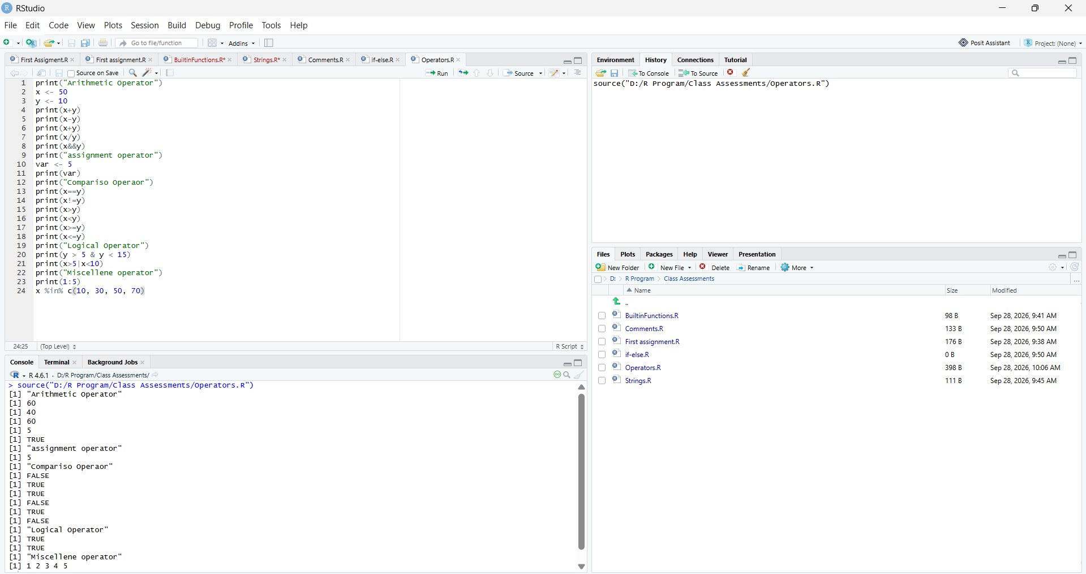
Arithmetic Operator:
Arithmetic operators are used with numeric values to perform common mathematical operations:
Operator | Name | Example
+ | Addition | x + y
- | Subtraction | x - y
* | Multiplication | x * y
/ | Division | x / y
^ | Exponent | x ^ y
%% | Modulus (Remainder from division) | x %% y
R – Program
print("Arithmetic Operator")
x <- 50
y <- 10
print(x+y)
print(x-y)
print(x+y)
print(x/y)
print(x&&y)
Output:
[1] "Arithmetic Operator"
[1] 60
[1] 40
[1] 60
[1] 5
[1] TRUE

Assignment operators:
Assignment operators are used to assign values to variables:

R - Program
print("assignment operator")
var <- 5
print(var)

Output:
[1] "assignment operator"
[1] 5

Comparison Operator
Comparison operators are used to compare two values:
Operator | Name | Example
== | Equal | x == y
!= | Not equal | x != y
> | Greater than | x > y
< | Less than | x < y
>= | Greater than or equal to | x >= y
<= | Less than or equal to | x <= y
R - Program
print("Comparison Operator")
print(x==y)
print(x!=y)
print(x>y)
print(x<y)
print(x>=y)
print(x<=y)

Output:
[1] "Comparison Operaor"
[1] FALSE
[1] TRUE
[1] TRUE
[1] FALSE
[1] TRUE
[1] FALSE

Logical Operator:
Logical operators are used to combine conditional statements:
Operator | Description
& | Element-wise Logical AND operator. Returns TRUE if both elements are TRUE
&& | Logical AND operator - Returns TRUE if both statements are TRUE
| | Elementwise- Logical OR operator. Returns TRUE if one of the statements is TRUE
|| | Logical OR operator. Returns TRUE if one of the statements is TRUE
! | Logical NOT - Returns FALSE if statement is TRUE

R - Program
print("Logical Operator")
print(y > 5 & y < 15)
print(x>5|x<10)

Output:
[1] "Logical Operator"
[1] TRUE
[1] TRUE

Miscellaneous Operators
Miscellaneous operators are used to manipulate data:
Operator | Description
: | Creates a series of numbers in a sequence
%in% | Find out if an element belongs to a vector

R - Program
print("Miscellaneous operator")
print(1:5)
x %in% c(10, 30, 50, 70)

Output:
[1] " Miscellaneous operator"
[1] 1 2 3 4 5

